Assessment for Selenium

**Application**: Online Banking

**URL**: <http://demo.testfire.net/bank/login.aspx>

**Username**: jsmith

**Password**: Demo1234

**Requirement**: To create an automation testing solution to test an end to end scenario.

**Tools and Technology**: Selenium Webdriver, Java, TestNG

**Total time: 3hrs**

**Marks Weightage:**

Automation approach and Page Object Model: 50%

TestNG usage: 20 %

Test data management: 15%

Locators: 15%

**Following test cases need to be automated:**

## Login Page

1. On the login page, verify that AltoroMutual logo image is displayed in top left
2. Verify that following four tabs are displayed at the top: ONLINE BANKING LOGIN, PERSONAL, SMALL BUSINESS and INSIDE ALTORO MUTUAL
3. Verify that when user enters incorrect username and password then following Login Failed message should be displayed.

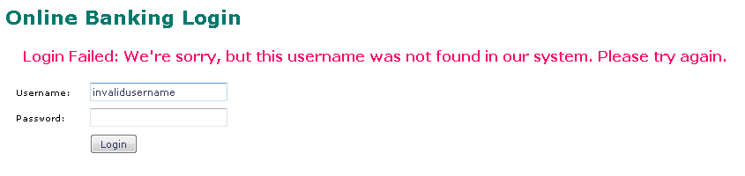

1. Verify that when user enters valid username and password then Online Banking Home page should be displayed.

## Online Banking Home

1. Select a bank account in View Account Details dropdown and click on GO button
2. Verify Account Information page is displayed. Also verify that account number displayed in heading **Account History - <Account no.>** is same as bank account selected in above step
3. Verify that current date is displayed in Balance Detail table (Ending balance as of <Date>)

## Transfer Funds Page

1. Click on Transfer Funds link in left hand navigation section, verify that Transfer Funds page is displayed
2. Select From Account, To Account and Amount to Transfer and click on Transfer Money button
3. Verify that a message is displayed with correct amount and from/to account details



## Account Information page

1. Click on View Account Summary link in left hand navigation section
2. Select **From account** (same as used before) in the dropdown and click on GO button
3. Verify that an entry is present in the Debits table for transaction done on Transfer Funds page. Verify that the amount is same as entered while transferring funds.

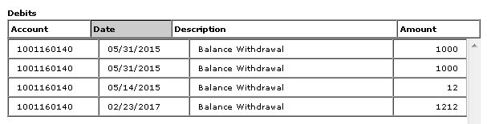

1. Select **To Account** (same as used before) in dropdown present inside Balance Detail table and click on Select Account button.

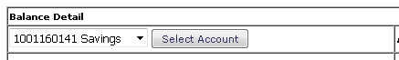

1. Verify that an entry is present in the Credits table for transaction done on Transfer Funds page. Verify that the amount is same as entered while transferring funds.

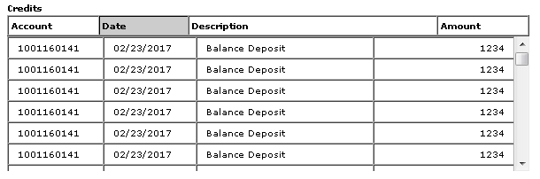

1. Click on Sign off link at the top and verify that user is signed off.

**Notes**:

1. Application url, username and password should be fetched from a configuration file.
2. For validations use TestNG default assertions
3. Implement the Page Object Design Pattern
4. Use System.out.println where you have to print the details like booking number
5. Execution should be done using TestNG xml